🟢 Bandit Level 7 → Level 8
You need to find the password in data.txt, next to the word millionth.
Run:
ls to view the files
You should see:
data.txt
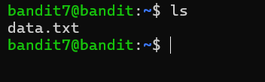
Then:
grep millionth data.txt
You'll get:
millionth <password>
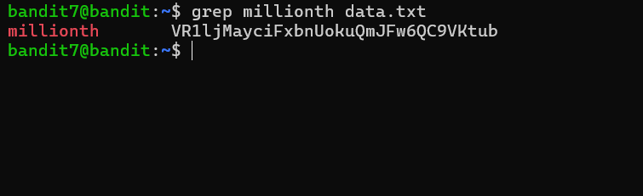
👉 The value after millionth is your Bandit Level 8 password is VR1ljMayciFxbnUokuQmJFw6QC9VKtub
Then exit

